BLOGPOST - 3 Awesome MVPs

3 Awesome Minimum Viable Products (MVPs)
Video: https://www.youtube.com/watch?v=xPJoq_QVsY4

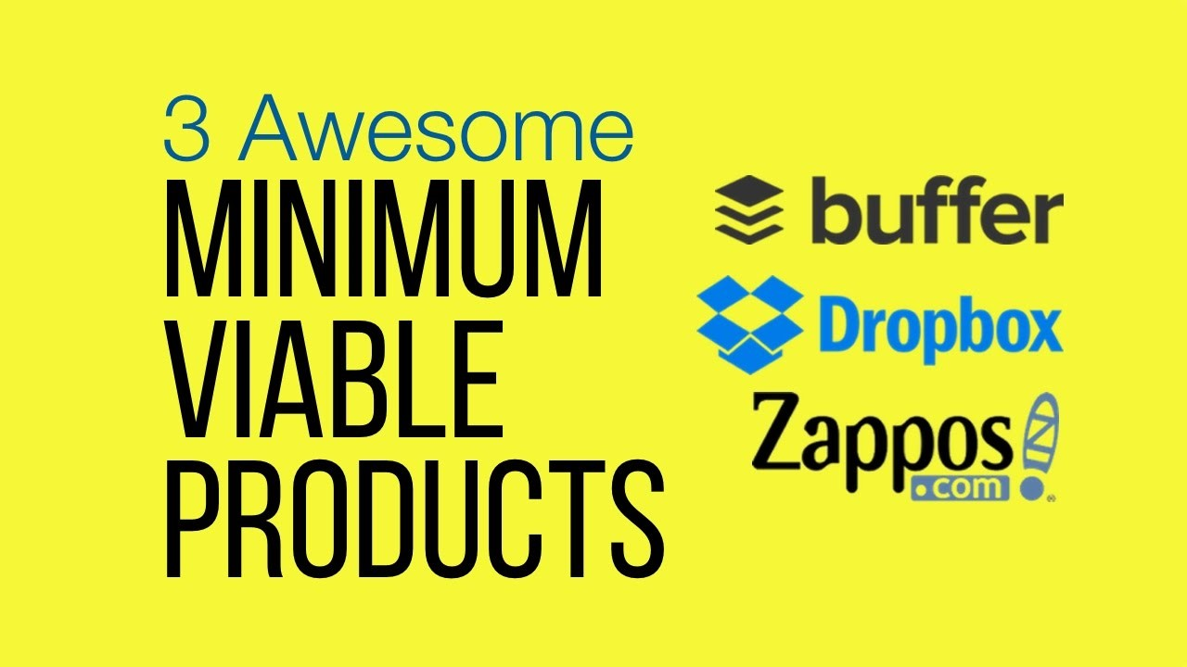

Description
35. 3 Awesome Minimum Viable Products (MVPs) // What are the best MPVs of all time? I've absolutely no idea... but Buffer, Dropbox and Zappos are three of my favourites.

➽ SUBSCRIBE for a NEW VIDEO every WEDNESDAY: http://www.DevelopmentThatPays.com/-/...
0:15 - Ground rules for a perfect MVP
1:00 - Buffer
1:58 - Dropbox
3:23 - Zappos

LINKS
- Steven Cohn: https://www.linkedin.com/pulse/death-...
- Buffer: https://blog.bufferapp.com/idea-to-pa...
- Dropbox: http://techcrunch.com/2011/10/19/drop...
- Zappos: http://www.bullethq.com/blog/lean-sta...

What are the best Minimum Viable Products of all time I've no idea (!) But here are three of my favourites. Top 3 ----- Today, we're going to take a look at three of my favourite examples of Minimum Viable Products (MVPs). Before diving in. let's establish some ground rules for a "proper" MVP It's got to be Minimal It's got to be Viable And it's got to be a Prod... Actually No, it does not need to be a Product. (I'll be showing you a great example of a non-product in a minute or two.) Some have argued that the word "Product" in MVP is unhelpful. Steven Cohn has made a strong case for the word "Experiment". I agree. But for now let's stick with the "P" and temporarily re-define it to.... Pre-meditated. Meaning that the MVP must be a deliberate attempt to learn about the market. This rules out cases that look like MVPs in retrospect, but were really full products that - to everyone's surprise - developed into something big. Let's get going. No. 3 - Buffer ------ Buffer is a application that makes it easy to share content on social media. Here's what they put on the their site. A test, certainly. But it falls short of an MVP in my opinion. Their next test was better. They slotted this page in-between the other two pages. Now visitors to the website are not just saying "This is interesting" They're saying "I want to BUY this". Okay, there's nowhere to input your credit card details. But anyone who got this far was at least prepared to think about parting with their money. As co-founder Joel Gascoigne said: "After this result, I didn’t hesitate to start building the first minimal version of the real, functioning product." Minimal - certainly Viable - yes Pre-mediated - check Buffer's current valuation is something close to $400 million No. 2 - Dropbox ---- Dropbox, as I'm sure you know, is a file synchronisation service. Edit a file on your desktop... ... and seconds later its updated on all of your other devices. Rewind to the early days. The team - entirely composed of techies - had the basic synchronisation working. That was the easy bit. The hard bit was going to be to achieve the same trick on pretty well every platform: Mac, Windows, iPhone, etc. Given that the team was all techies, you'd have put money on them diving straight in. But CEO Drew Houston did something surprising. He made a video. The video - just three minutes long - demonstrated the synch process end to end. But it was more than just a demo: it was full of techie in-jokes... designed to appeal to early adopters. It worked like a charm In Drew's words: “It drove hundreds of thousands of people to the website. Our beta waiting list went from 5,000 people to 75,000 people literally overnight. It totally blew us away.” Minimal - Yes Viable - Not a product that could be used, but a product that could be demonstrated. Pre-Meditated - Yes Dropbox went on to do quite well. It's current value stands between $5 and $10 BILLION. No. 1 - Zappos ---- It's 1999. Co-founder Nick Swinmurn wanted to build an online store for shoes. But would people use it Here's how he went about finding out. He popped down to lis local shoe shops he went into the shops and... ... I sh!t you not... he PHOTOGRAPHED PAIRS OF SHOES! The photos were uploaded to a super-simple website. If someone clicked on the button to buy a pair Nick would pop down to the store and... BUY THE SHOES! Zero infrastructure. Zero inventory. Minimal - definitely Viable - This time it's not even up for discussion. Most definitely: real customers; real money changing hands; real shoes! Pre-meditated Check. Zappos went on to do quite well: it was acquired by Amazon in 2009 for a cool $1.2 billion. Your thoughts, please! ---- Buffer, Dropbox and Zappos. Three of my favourite MVPs. What do you think of my choices Any you disagree with Let me know in the comments. And I'd also like to hear about your favourites. Again, let me know in th
https://www.youtube.com/DevelopmentTh... https://www.youtube.com/watch?v=xPJoq... https://www.youtube.com/watch?v=cjCCS...

Aus <https://www.youtube.com/watch?v=xPJoq_QVsY4>

